Build a Security Monitoring System on AWS
CloudTrail | CloudWatch | SNS
Hamsa Isa | Project Documentation
I built a monitoring system that detects when a secret in AWS Secrets Manager is accessed, and sends me a real-time email alert when it happens — using CloudTrail for logging, CloudWatch for filtering and alarming, and SNS for notification.

Step 1: Create a Secret
I created a secret in Secrets Manager — the resource I want to monitor access to for the rest of the project.
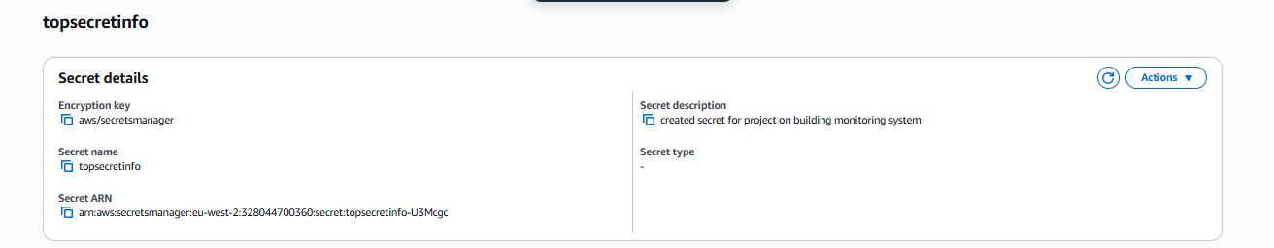
Secret “topsecretinfo” created in Secrets Manager
Why: This is the thing we're protecting — everything else in this project exists to detect and alert on access to it.

Step 2: Configure CloudTrail
I set up a CloudTrail trail to track account activity — specifically Management events, since accessing a secret falls into that category and is free to track.
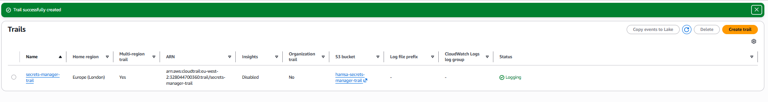
Trail “secrets-manager-trail” created and logging
Why: CloudTrail is the “eyes” of the account — without it, nothing downstream has anything to detect.

Step 3: Generate and Verify Secret Access Events
To test whether CloudTrail was actually working, I accessed the secret via the AWS CLI, triggering the GetSecretValue API call directly.
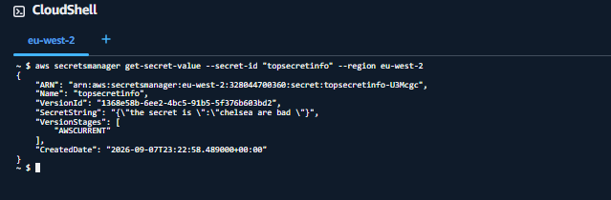
Retrieving the secret via CLI in CloudShell
I then checked CloudTrail's Event History and confirmed the GetSecretValue event was captured.
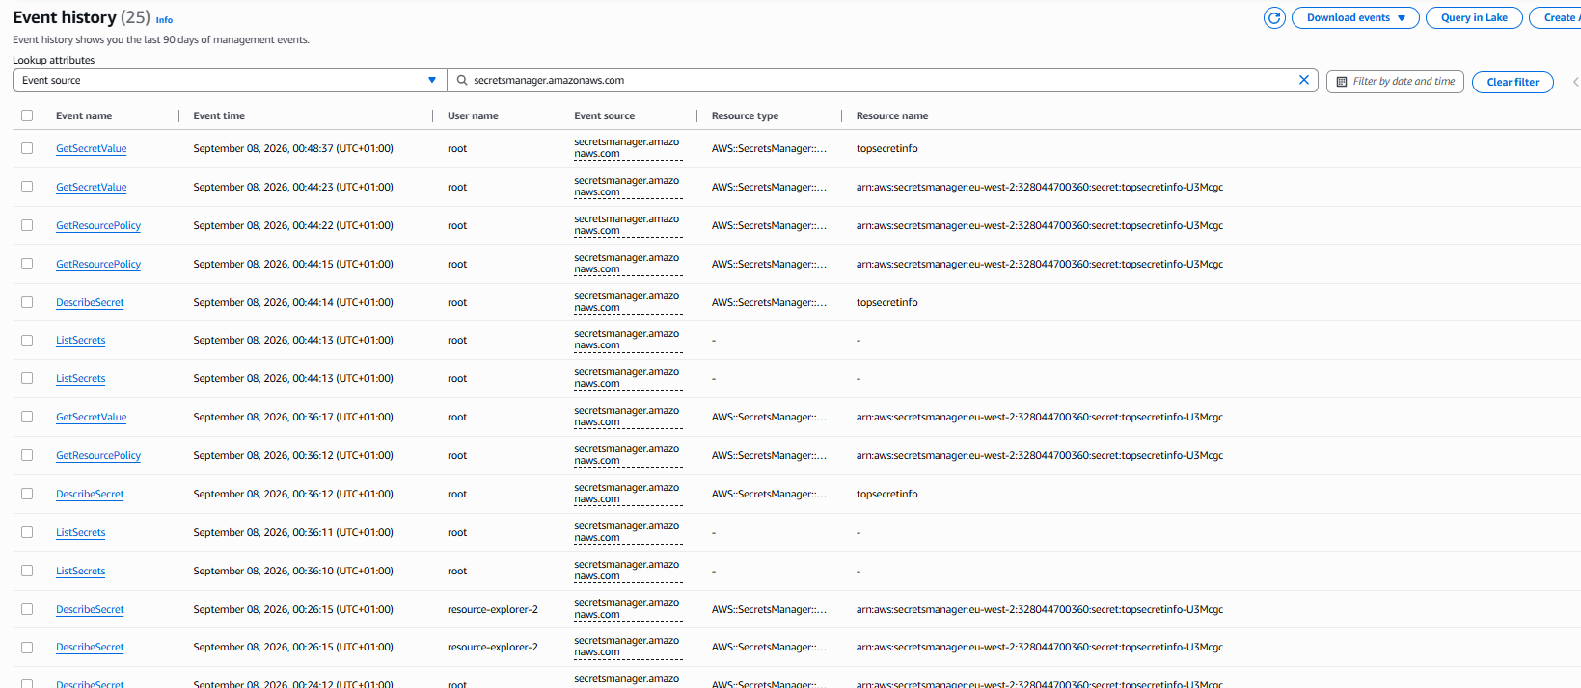
Event History showing GetSecretValue events logged
Why: This confirms CloudTrail actually caught the access — proving the pipeline before building anything on top of it.

Step 4: Track Secret Access Using CloudWatch
I created a CloudWatch metric filter to turn matching CloudTrail log lines into a trackable number.
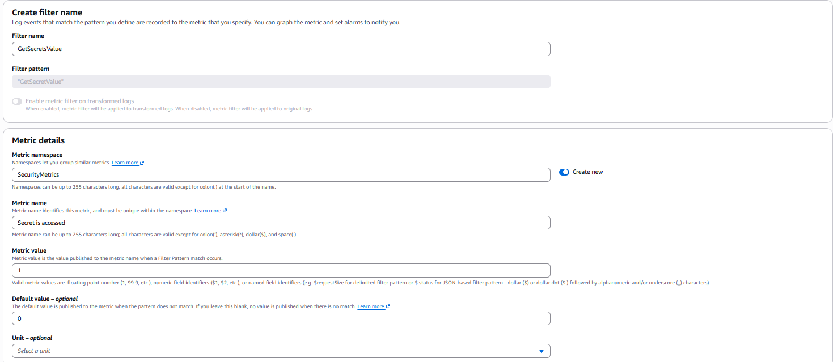
Metric filter matching “GetSecretValue”, incrementing the SecurityMetrics namespace
Filter pattern: "GetSecretValue" | Metric value: 1 | Default value: 0
Why: The filter turns a raw log line into a countable metric — this is what the alarm in the next step actually watches.

Step 5: Create CloudWatch Alarm and SNS Topic
I created an alarm that triggers when the metric crosses a threshold of 1, and an SNS topic to email me when that happens.
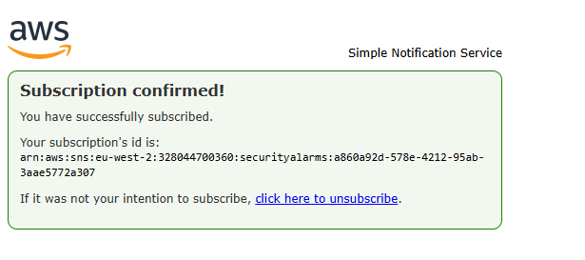
SNS email subscription confirmed
Why: AWS requires this confirmation step so nobody can be subscribed to notifications without their consent.

Step 6: Test and Troubleshoot
On the first end-to-end test, no email arrived — even though everything looked correctly configured. I worked through the pipeline step by step to isolate the fault:
- 1. Checked CloudTrail's Event History again — the access was being logged correctly.
- 2. Checked the trail's delivery status to CloudWatch — logs were arriving in the log group as expected.
- 3. Tested the metric filter directly against sample log data — it correctly matched only GetSecretValue events.
- 4. Manually forced the alarm into ALARM state via the CLI — this successfully sent an email, confirming the alarm-to-SNS link worked.
- 5. Published a raw test message directly to the SNS topic, bypassing CloudWatch entirely — confirming SNS itself could deliver messages.
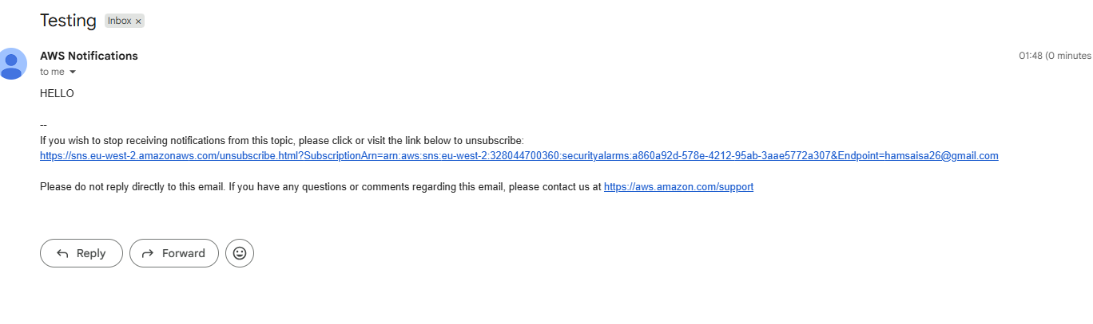
Direct SNS test message delivered successfully
With every individual link confirmed working, the fault had to be in how the alarm evaluated the metric. The alarm's statistic was set to Average instead of Sum — so one access in a 60-second period came out as a tiny fraction (around 0.002) that never crossed the threshold of 1. Switching the statistic to Sum fixed the calculation.
Why: Isolating each link in the chain rather than guessing is the same evidence-based process used when investigating why a security alert isn't firing as expected.

Final Test: Success
I accessed the secret one more time and confirmed the alarm now fired correctly, with the alert email arriving within minutes.
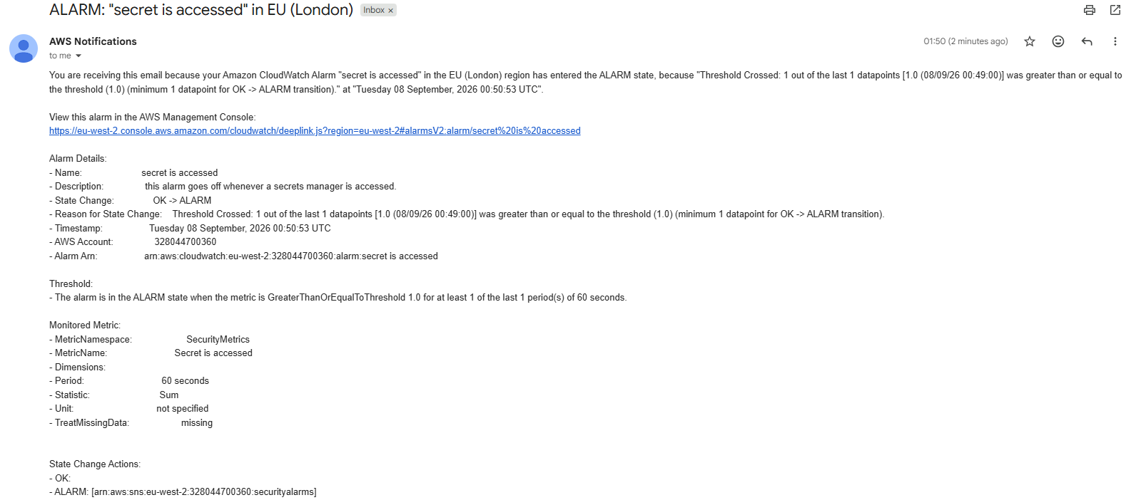
Alarm email received — statistic now correctly shows Sum, threshold crossed as expected

Bonus: CloudTrail Direct-to-SNS Comparison
As an extension, I enabled CloudTrail's built-in direct SNS notification option, which bypasses CloudWatch entirely.
Raw notification — only tells you a new log file was delivered, not what it contains
Why: This showed why CloudWatch's targeted alarm is the better design: direct notifications fire on every single log delivery with no filtering, while the CloudWatch alarm only alerts on the exact event that actually matters.

Result
The system successfully detects secret access and sends a real-time email alert — built and verified end-to-end, including diagnosing and fixing a real configuration error along the way.

